Database Assignment 1

Note : Use Emp, dept and salgrade table

1. To list all records with sal > 2000 and comm>200.

-> select * from emp where sal > 2000 and comm > 200;

Empty set (0.00 sec)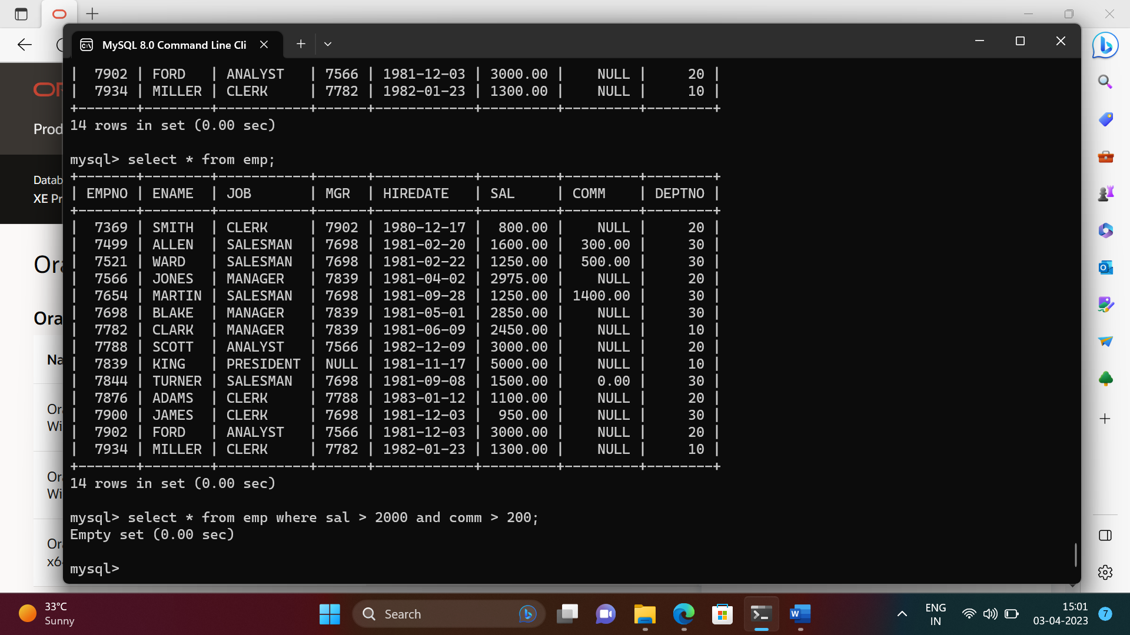

1. To list all record with job=’Clerk’ or sal>2000.

-> select * from emp where job = 'clerk' and sal > 2000;

Empty set (0.00 sec)

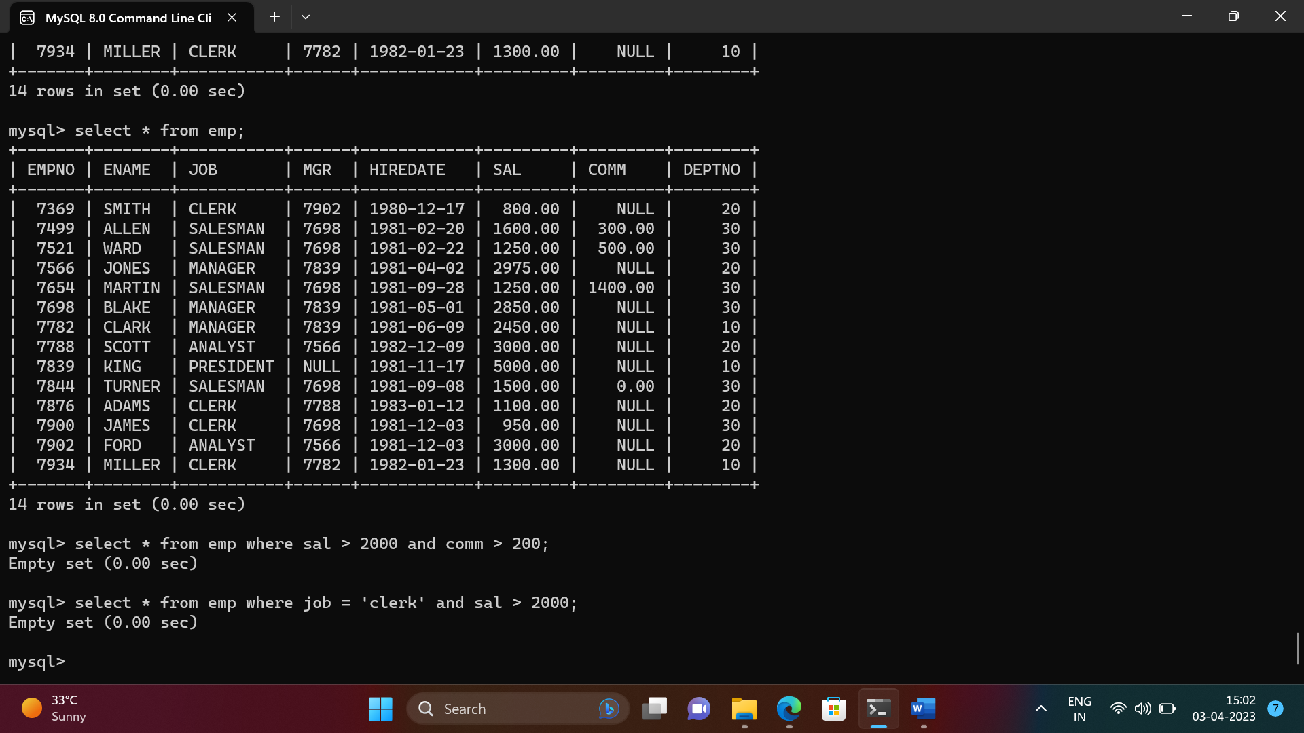

1. To list all the record with sal=1250 or 1100 or 2850

-> select * from emp where sal in (1250,1100,2850);

+-------+--------+----------+------+------------+---------+---------+--------+

| EMPNO | ENAME | JOB | MGR | HIREDATE | SAL | COMM | DEPTNO |

+-------+--------+----------+------+------------+---------+---------+--------+

| 7521 | WARD | SALESMAN | 7698 | 1981-02-22 | 1250.00 | 500.00 | 30 |

| 7654 | MARTIN | SALESMAN | 7698 | 1981-09-28 | 1250.00 | 1400.00 | 30 |

| 7698 | BLAKE | MANAGER | 7839 | 1981-05-01 | 2850.00 | NULL | 30 |

| 7876 | ADAMS | CLERK | 7788 | 1983-01-12 | 1100.00 | NULL | 20 |

+-------+--------+----------+------+------------+---------+---------+--------+

4 rows in set (0.00 sec)

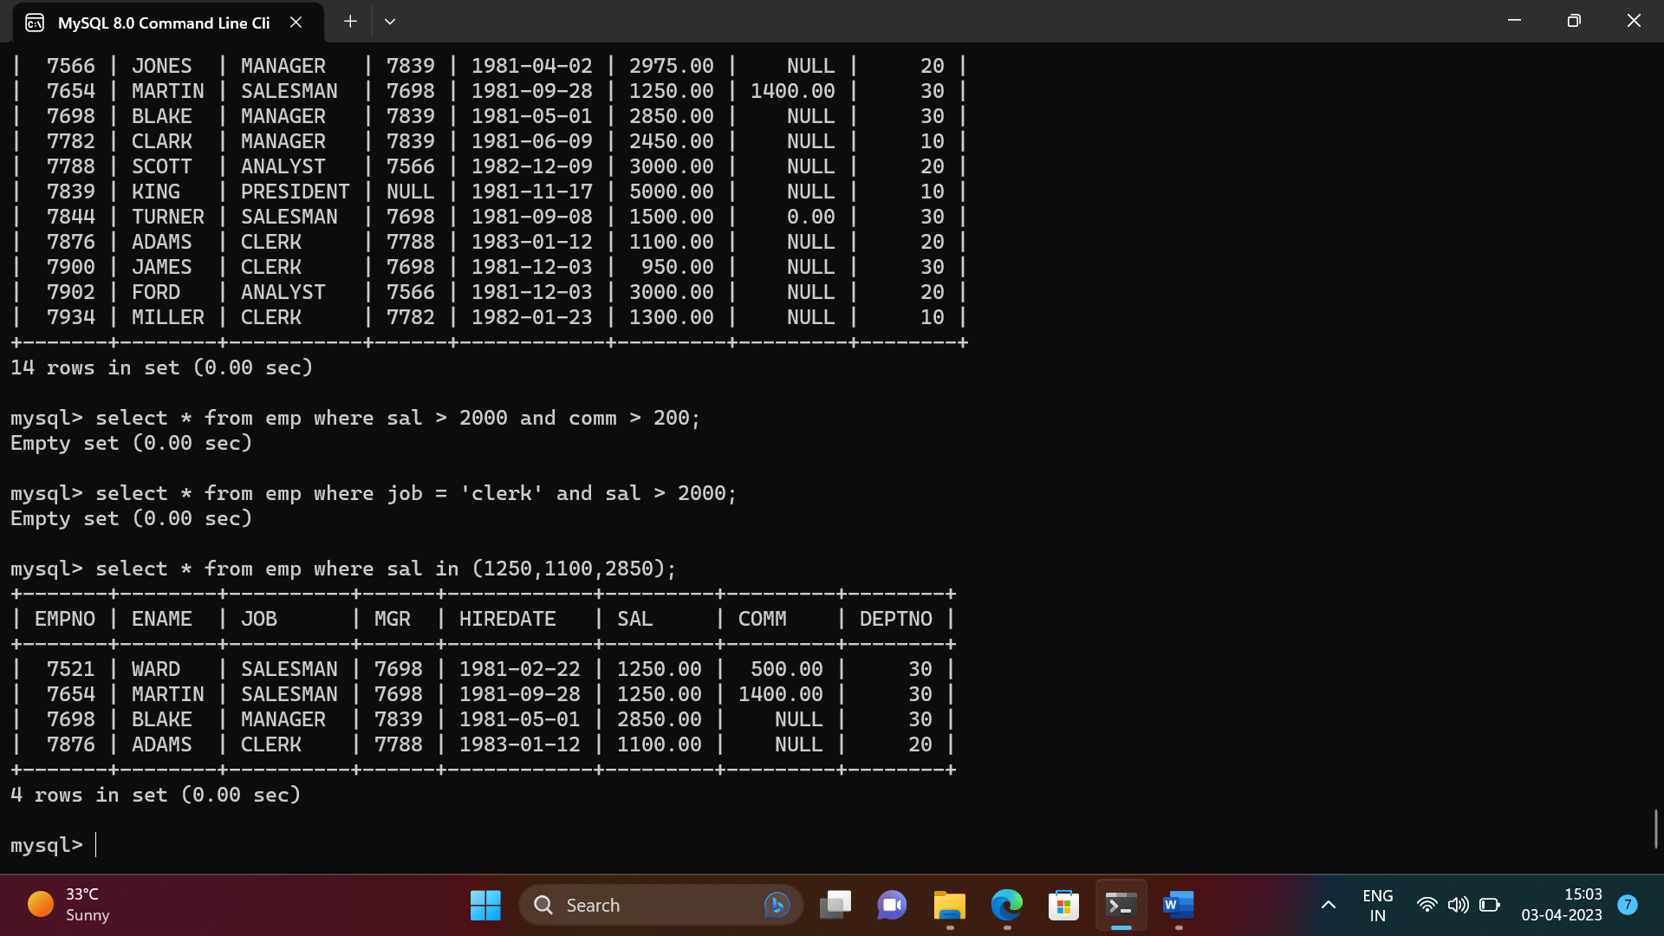

1. To list all employees with sal>1250 and <2850

-> select * from emp where sal between 1250 AND 2850;

+-------+--------+----------+------+------------+---------+---------+--------+

| EMPNO | ENAME | JOB | MGR | HIREDATE | SAL | COMM | DEPTNO |

+-------+--------+----------+------+------------+---------+---------+--------+

| 7499 | ALLEN | SALESMAN | 7698 | 1981-02-20 | 1600.00 | 300.00 | 30 |

| 7521 | WARD | SALESMAN | 7698 | 1981-02-22 | 1250.00 | 500.00 | 30 |

| 7654 | MARTIN | SALESMAN | 7698 | 1981-09-28 | 1250.00 | 1400.00 | 30 |

| 7698 | BLAKE | MANAGER | 7839 | 1981-05-01 | 2850.00 | NULL | 30 |

| 7782 | CLARK | MANAGER | 7839 | 1981-06-09 | 2450.00 | NULL | 10 |

| 7844 | TURNER | SALESMAN | 7698 | 1981-09-08 | 1500.00 | 0.00 | 30 |

| 7934 | MILLER | CLERK | 7782 | 1982-01-23 | 1300.00 | NULL | 10 |

+-------+--------+----------+------+------------+---------+---------+--------+

7 rows in set (0.00 sec)

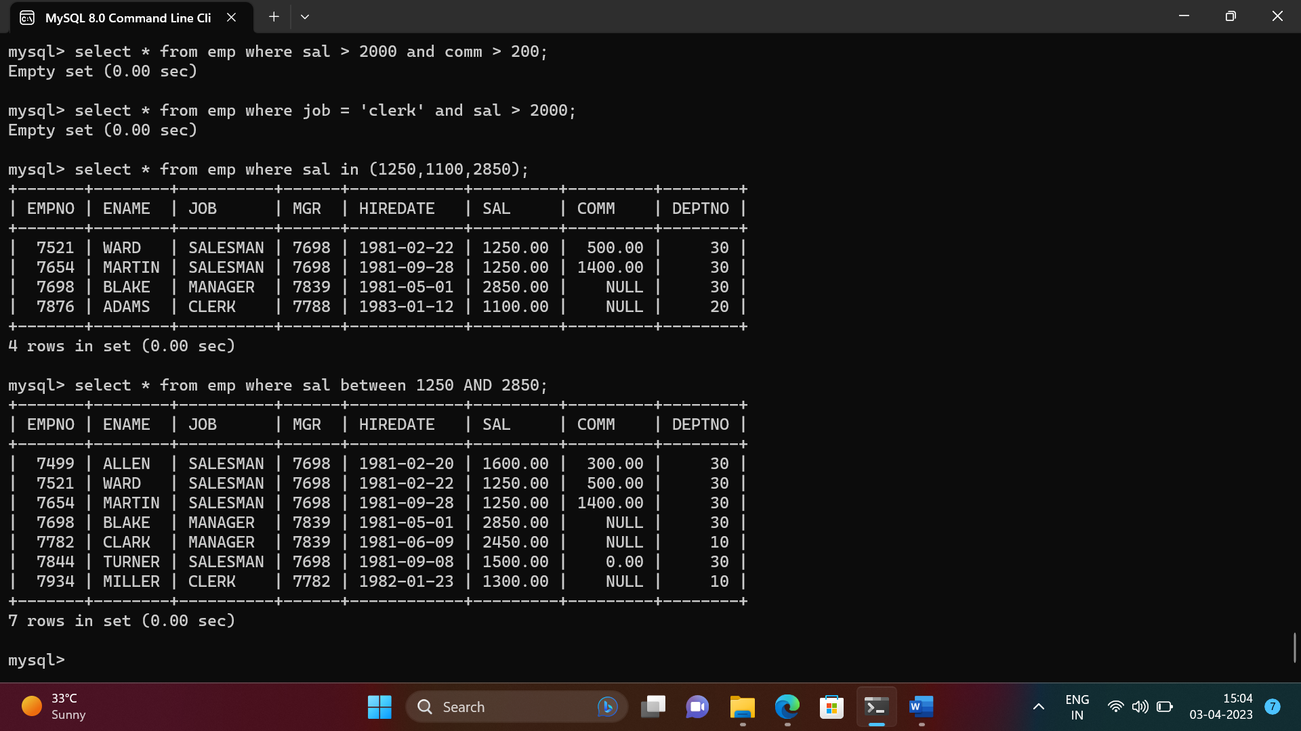

1. To list all employees with name ends with AS

-> select * from emp where ENAME like '%as';

Empty set (0.00 sec)

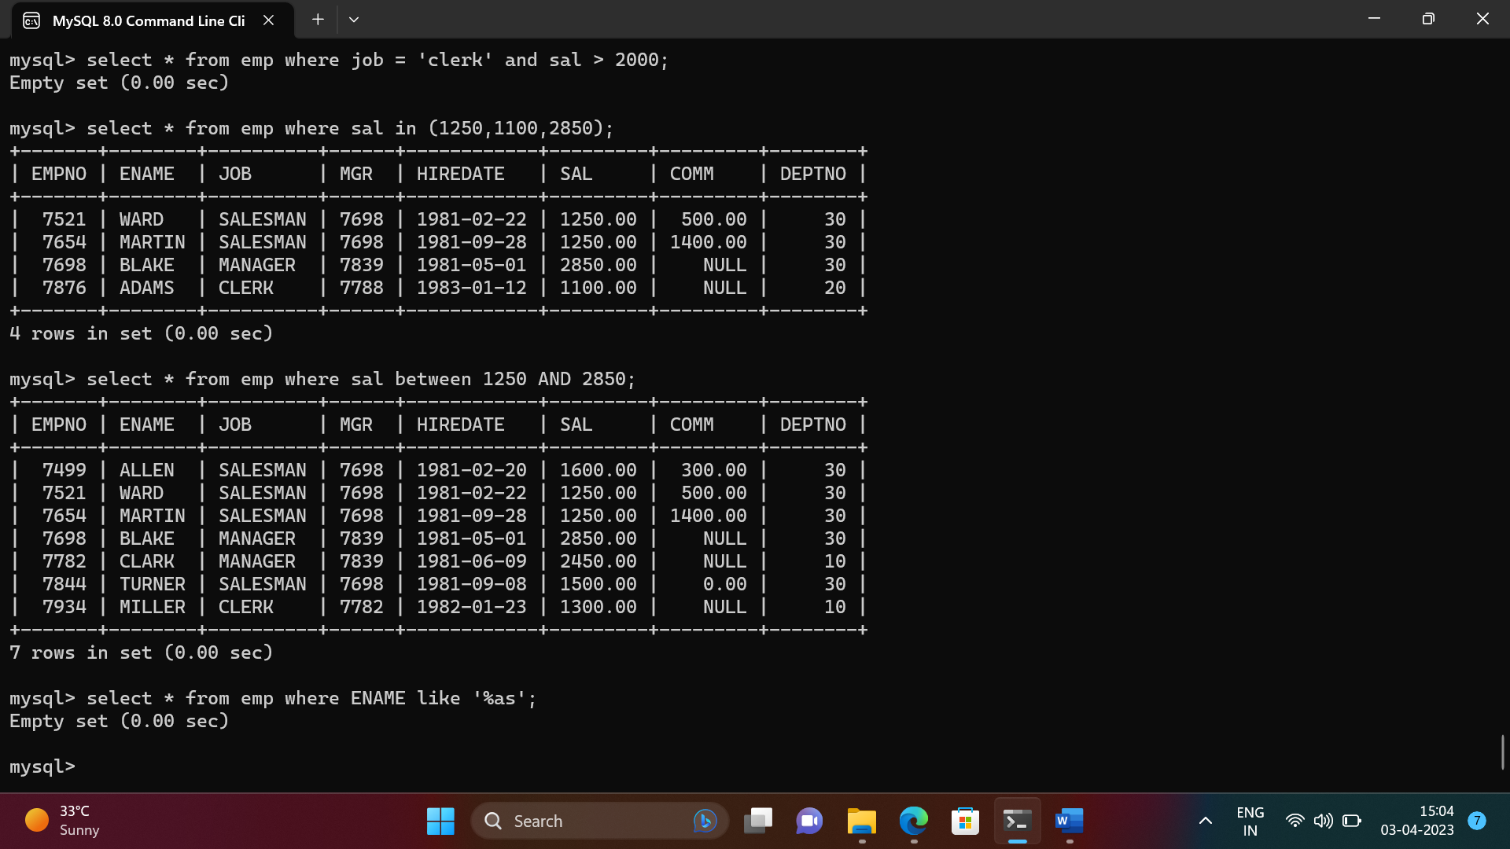

1. To list all employees with job starts with C and ends with K.

-> select * from emp where job like 'c%k';

+-------+--------+-------+------+------------+---------+------+--------+

| EMPNO | ENAME | JOB | MGR | HIREDATE | SAL | COMM | DEPTNO |

+-------+--------+-------+------+------------+---------+------+--------+

| 7369 | SMITH | CLERK | 7902 | 1980-12-17 | 800.00 | NULL | 20 |

| 7876 | ADAMS | CLERK | 7788 | 1983-01-12 | 1100.00 | NULL | 20 |

| 7900 | JAMES | CLERK | 7698 | 1981-12-03 | 950.00 | NULL | 30 |

| 7934 | MILLER | CLERK | 7782 | 1982-01-23 | 1300.00 | NULL | 10 |

+-------+--------+-------+------+------------+---------+------+--------+

4 rows in set (0.00 sec)

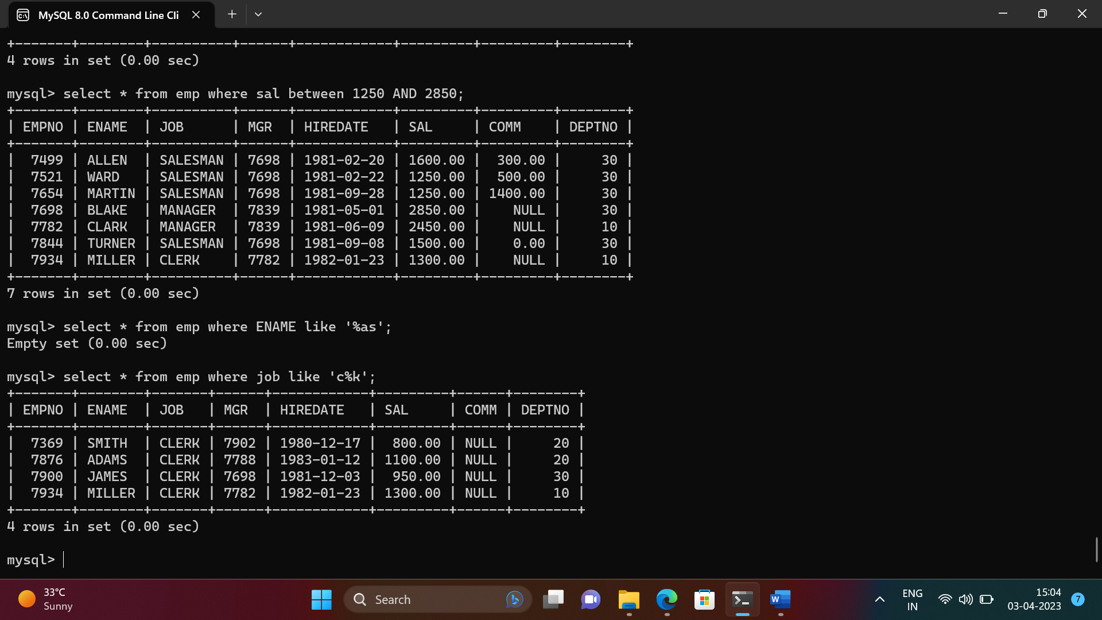

1. To list all employees with job contains L at third

position and M at third last position

-> select * from emp where job like '__l%m__';

+-------+--------+----------+------+------------+---------+---------+--------+

| EMPNO | ENAME | JOB | MGR | HIREDATE | SAL | COMM | DEPTNO |

+-------+--------+----------+------+------------+---------+---------+--------+

| 7499 | ALLEN | SALESMAN | 7698 | 1981-02-20 | 1600.00 | 300.00 | 30 |

| 7521 | WARD | SALESMAN | 7698 | 1981-02-22 | 1250.00 | 500.00 | 30 |

| 7654 | MARTIN | SALESMAN | 7698 | 1981-09-28 | 1250.00 | 1400.00 | 30 |

| 7844 | TURNER | SALESMAN | 7698 | 1981-09-08 | 1500.00 | 0.00 | 30 |

+-------+--------+----------+------+------------+---------+---------+--------+

4 rows in set (0.00 sec)

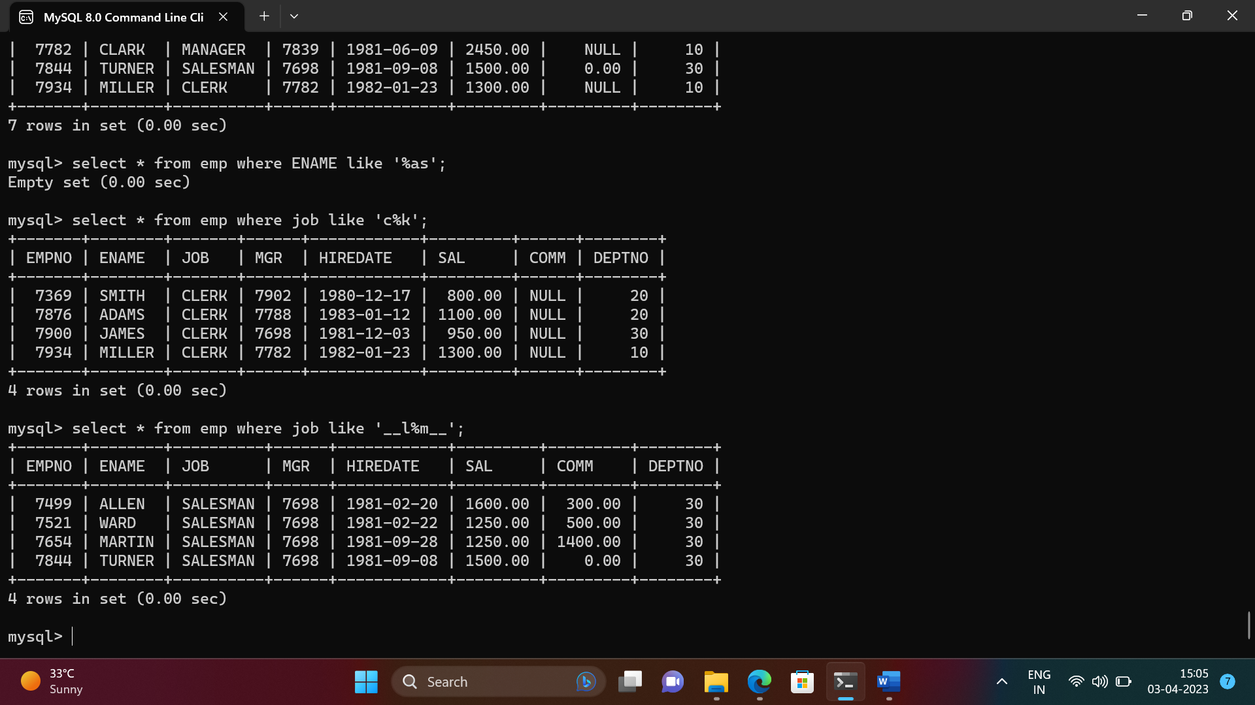

1. To list all the record with sal not equal to 1250 or 1100 or 2850

-> select * from emp where sal not in (1250,1100,2850);

+-------+--------+-----------+------+------------+---------+--------+--------+

| EMPNO | ENAME | JOB | MGR | HIREDATE | SAL | COMM | DEPTNO |

+-------+--------+-----------+------+------------+---------+--------+--------+

| 7369 | SMITH | CLERK | 7902 | 1980-12-17 | 800.00 | NULL | 20 |

| 7499 | ALLEN | SALESMAN | 7698 | 1981-02-20 | 1600.00 | 300.00 | 30 |

| 7566 | JONES | MANAGER | 7839 | 1981-04-02 | 2975.00 | NULL | 20 |

| 7782 | CLARK | MANAGER | 7839 | 1981-06-09 | 2450.00 | NULL | 10 |

| 7788 | SCOTT | ANALYST | 7566 | 1982-12-09 | 3000.00 | NULL | 20 |

| 7839 | KING | PRESIDENT | NULL | 1981-11-17 | 5000.00 | NULL | 10 |

| 7844 | TURNER | SALESMAN | 7698 | 1981-09-08 | 1500.00 | 0.00 | 30 |

| 7900 | JAMES | CLERK | 7698 | 1981-12-03 | 950.00 | NULL | 30 |

| 7902 | FORD | ANALYST | 7566 | 1981-12-03 | 3000.00 | NULL | 20 |

| 7934 | MILLER | CLERK | 7782 | 1982-01-23 | 1300.00 | NULL | 10 |

+-------+--------+-----------+------+------------+---------+--------+--------+

10 rows in set (0.00 sec)

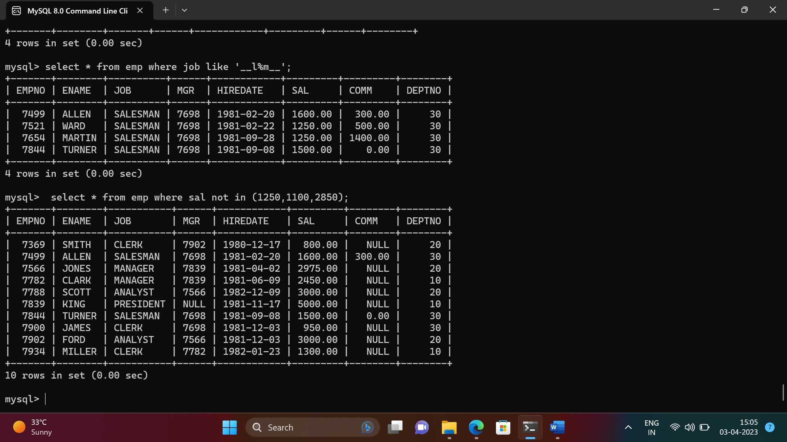

1. To list all employees with sal not >1250 and <2850

-> select * from emp where sal not between 1250 AND 2850;

+-------+-------+-----------+------+------------+---------+------+--------+

| EMPNO | ENAME | JOB | MGR | HIREDATE | SAL | COMM | DEPTNO |

+-------+-------+-----------+------+------------+---------+------+--------+

| 7369 | SMITH | CLERK | 7902 | 1980-12-17 | 800.00 | NULL | 20 |

| 7566 | JONES | MANAGER | 7839 | 1981-04-02 | 2975.00 | NULL | 20 |

| 7788 | SCOTT | ANALYST | 7566 | 1982-12-09 | 3000.00 | NULL | 20 |

| 7839 | KING | PRESIDENT | NULL | 1981-11-17 | 5000.00 | NULL | 10 |

| 7876 | ADAMS | CLERK | 7788 | 1983-01-12 | 1100.00 | NULL | 20 |

| 7900 | JAMES | CLERK | 7698 | 1981-12-03 | 950.00 | NULL | 30 |

| 7902 | FORD | ANALYST | 7566 | 1981-12-03 | 3000.00 | NULL | 20 |

+-------+-------+-----------+------+------------+---------+------+--------+

7 rows in set (0.00 sec)

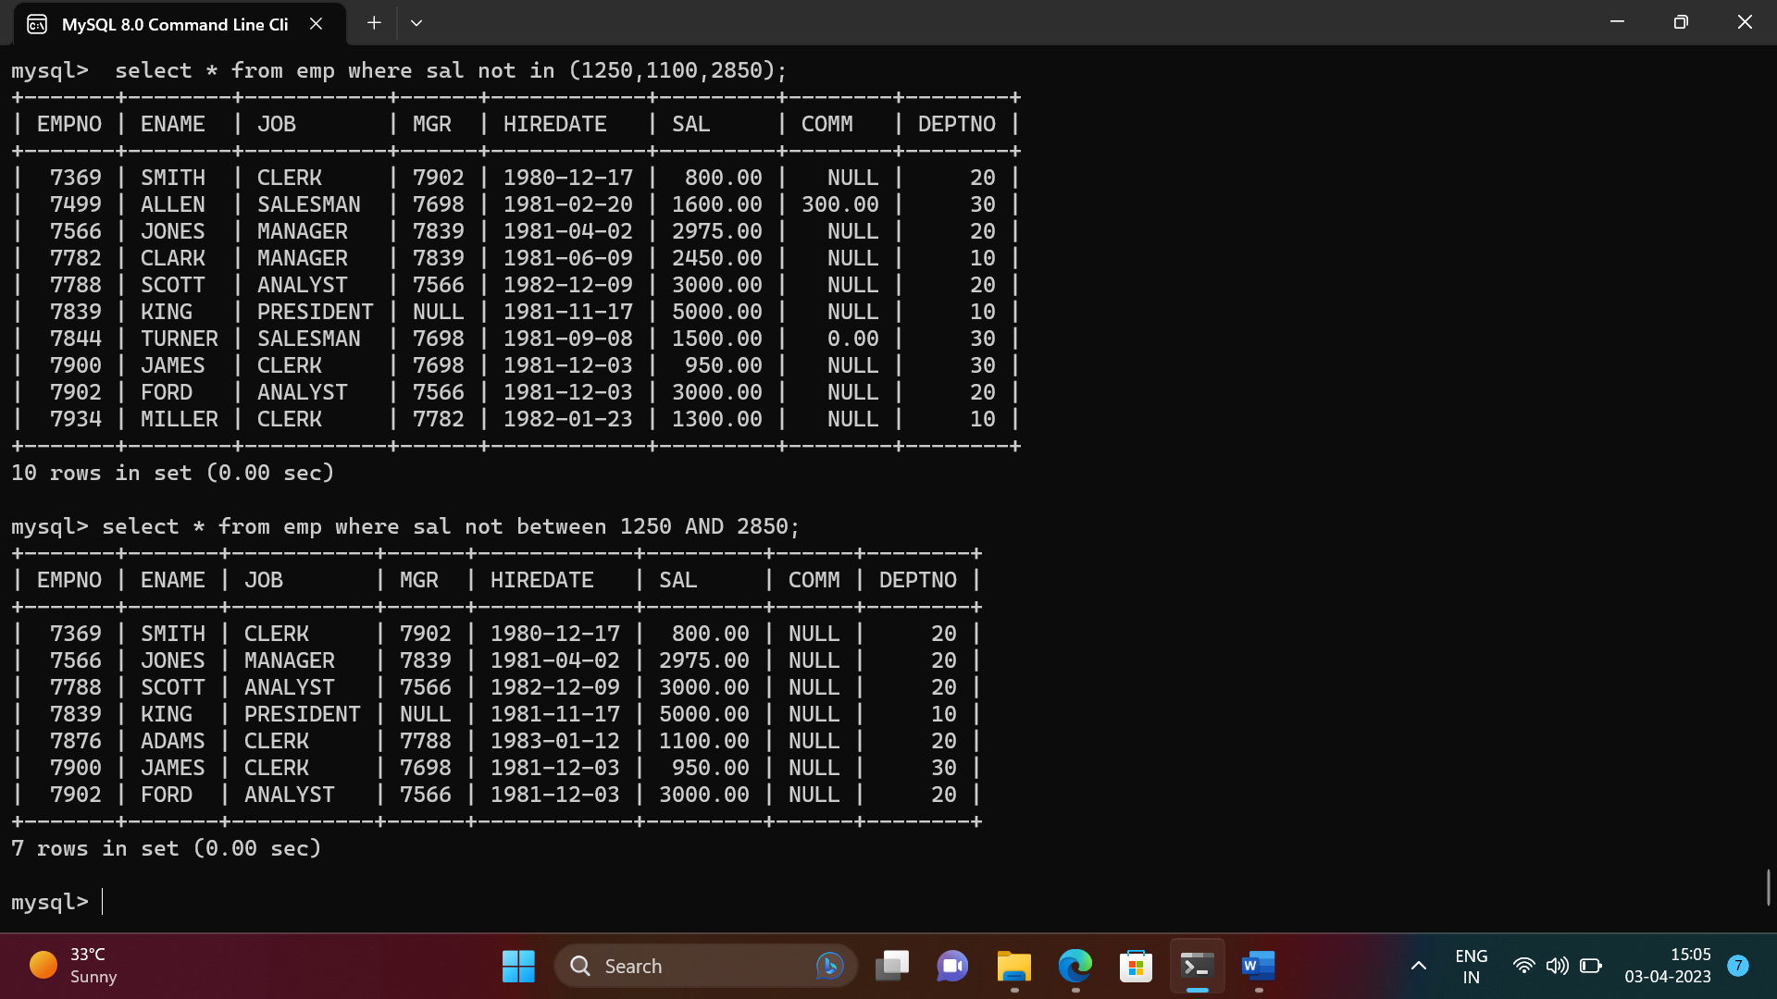

1. To list all employees with job starts with C , E at 3rd position and ends with K

-> select * from emp where job like 'c_e%k';

+-------+--------+-------+------+------------+---------+------+--------+

| EMPNO | ENAME | JOB | MGR | HIREDATE | SAL | COMM | DEPTNO |

+-------+--------+-------+------+------------+---------+------+--------+

| 7369 | SMITH | CLERK | 7902 | 1980-12-17 | 800.00 | NULL | 20 |

| 7876 | ADAMS | CLERK | 7788 | 1983-01-12 | 1100.00 | NULL | 20 |

| 7900 | JAMES | CLERK | 7698 | 1981-12-03 | 950.00 | NULL | 30 |

| 7934 | MILLER | CLERK | 7782 | 1982-01-23 | 1300.00 | NULL | 10 |

+-------+--------+-------+------+------------+---------+------+--------+

4 rows in set (0.00 sec)

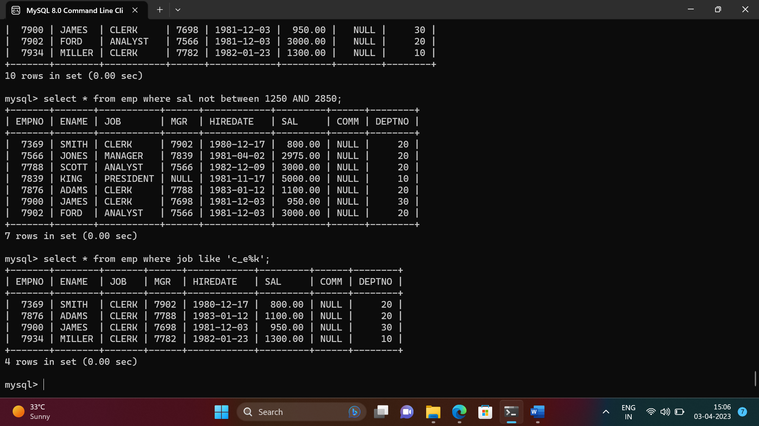

1. To list all rows with comm is null

-> select * from emp where comm is null;

+-------+--------+-----------+------+------------+---------+------+--------+

| EMPNO | ENAME | JOB | MGR | HIREDATE | SAL | COMM | DEPTNO |

+-------+--------+-----------+------+------------+---------+------+--------+

| 7369 | SMITH | CLERK | 7902 | 1980-12-17 | 800.00 | NULL | 20 |

| 7566 | JONES | MANAGER | 7839 | 1981-04-02 | 2975.00 | NULL | 20 |

| 7698 | BLAKE | MANAGER | 7839 | 1981-05-01 | 2850.00 | NULL | 30 |

| 7782 | CLARK | MANAGER | 7839 | 1981-06-09 | 2450.00 | NULL | 10 |

| 7788 | SCOTT | ANALYST | 7566 | 1982-12-09 | 3000.00 | NULL | 20 |

| 7839 | KING | PRESIDENT | NULL | 1981-11-17 | 5000.00 | NULL | 10 |

| 7876 | ADAMS | CLERK | 7788 | 1983-01-12 | 1100.00 | NULL | 20 |

| 7900 | JAMES | CLERK | 7698 | 1981-12-03 | 950.00 | NULL | 30 |

| 7902 | FORD | ANALYST | 7566 | 1981-12-03 | 3000.00 | NULL | 20 |

| 7934 | MILLER | CLERK | 7782 | 1982-01-23 | 1300.00 | NULL | 10 |

+-------+--------+-----------+------+------------+---------+------+--------+

10 rows in set (0.00 sec)

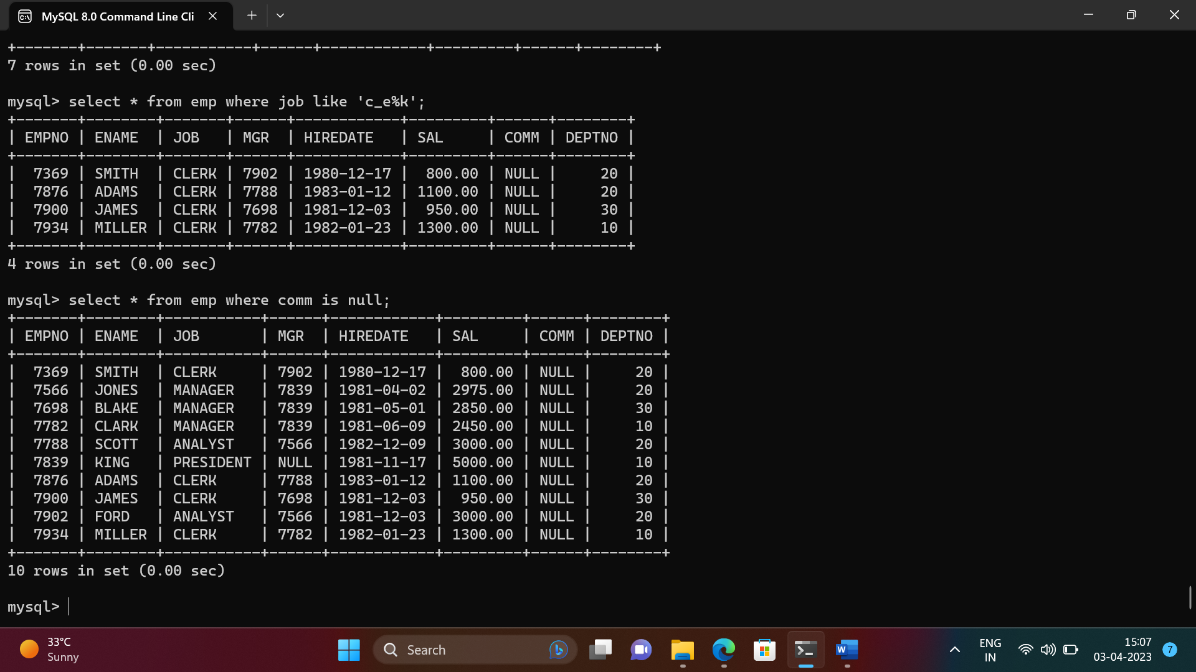

1. To list all employees with sal is null and name starts with ‘S’

-> select * from emp where sal =0.0 and ename like 'S%';

Empty set (0.00 sec)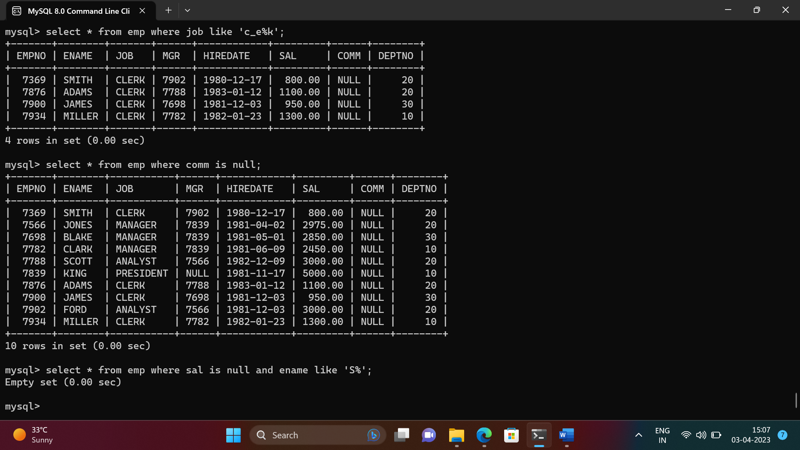

1. To list all employees with job contains 5 characters

-> select * from emp where length(job) = 5;

+-------+--------+-------+------+------------+---------+------+--------+

| EMPNO | ENAME | JOB | MGR | HIREDATE | SAL | COMM | DEPTNO |

+-------+--------+-------+------+------------+---------+------+--------+

| 7369 | SMITH | CLERK | 7902 | 1980-12-17 | 800.00 | NULL | 20 |

| 7876 | ADAMS | CLERK | 7788 | 1983-01-12 | 1100.00 | NULL | 20 |

| 7900 | JAMES | CLERK | 7698 | 1981-12-03 | 950.00 | NULL | 30 |

| 7934 | MILLER | CLERK | 7782 | 1982-01-23 | 1300.00 | NULL | 10 |

+-------+--------+-------+------+------------+---------+------+--------+

4 rows in set (0.00 sec) 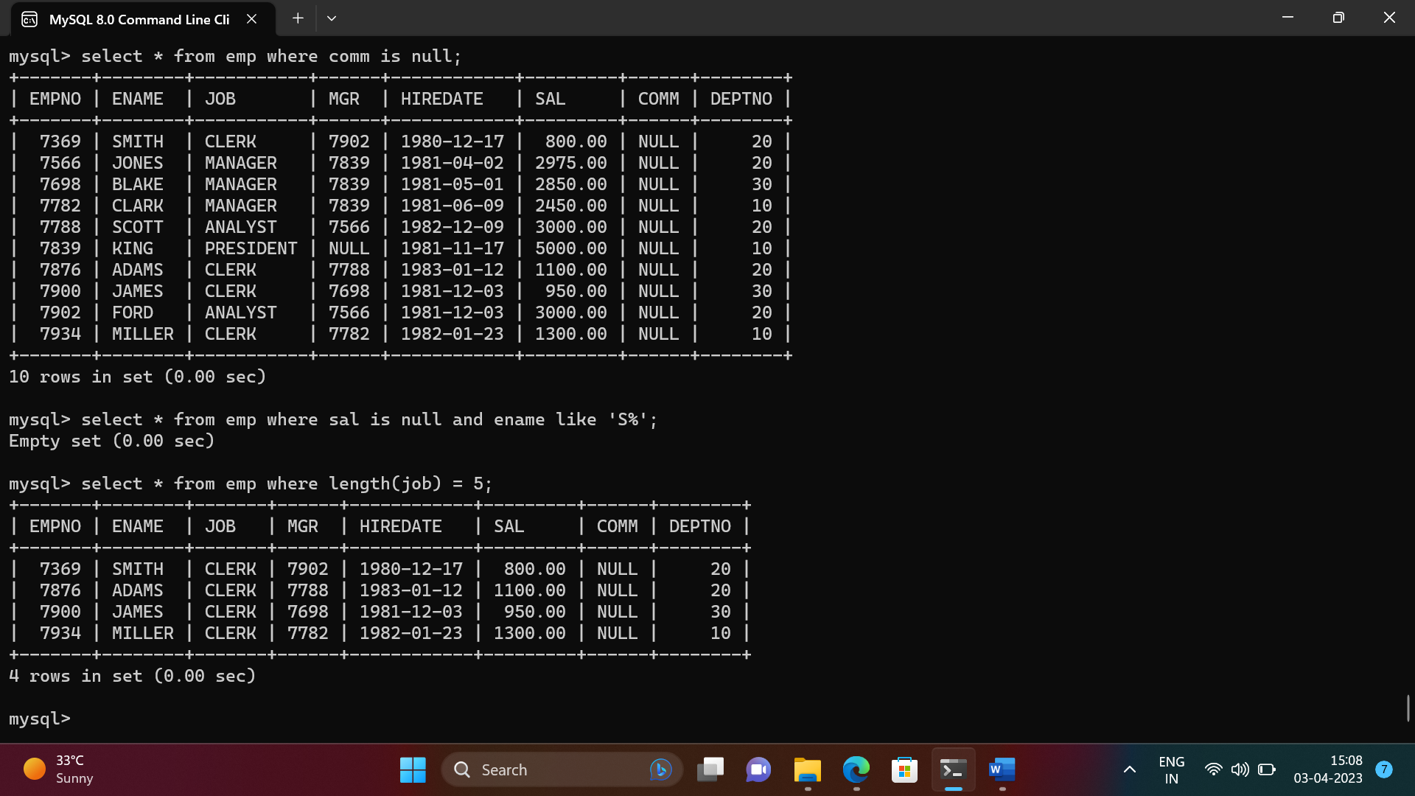

1. To list all employees with name contain ‘A’ at 1 position and job

Contains 5

-> 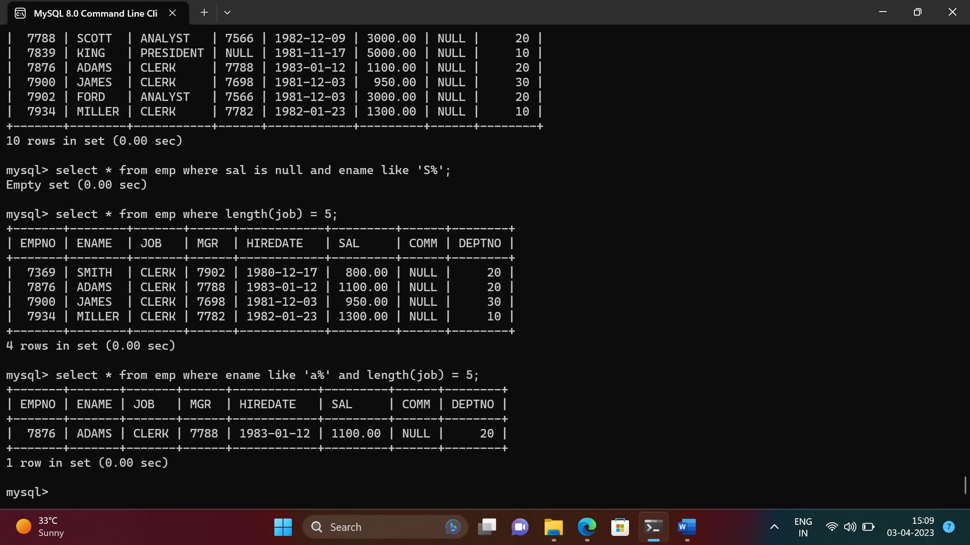

Characters Q2. Solve the following

* 1. Retrieve the details (Name, Salary and dept no) of the emp who are working in department code 20, 30 and 40.

-> select ename, sal, deptno from emp where deptno in (20,30,40);

+--------+---------+--------+

| ename | sal | deptno |

+--------+---------+--------+

| SMITH | 800.00 | 20 |

| ALLEN | 1600.00 | 30 |

| WARD | 1250.00 | 30 |

| JONES | 2975.00 | 20 |

| MARTIN | 1250.00 | 30 |

| BLAKE | 2850.00 | 30 |

| SCOTT | 3000.00 | 20 |

| TURNER | 1500.00 | 30 |

| ADAMS | 1100.00 | 20 |

| JAMES | 950.00 | 30 |

| FORD | 3000.00 | 20 |

+--------+---------+--------+

11 rows in set (0.00 sec)

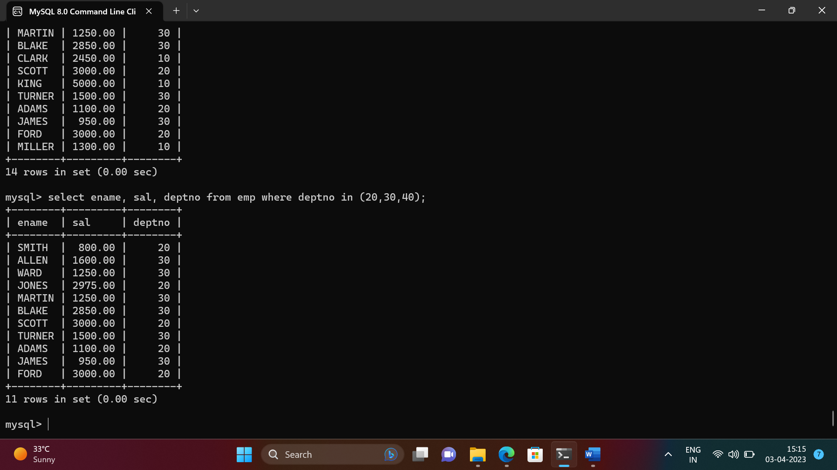

* 1. Display the total salary of all employees . Total salary will be calculated as sal+comm+sal*0.10

select empno, ename, sal, sal*0.1+sal+ifnull(comm,0) "total salary" from emp;

+-------+--------+---------+--------------+

| empno | ename | sal | total salary |

+-------+--------+---------+--------------+

| 7369 | SMITH | 800.00 | 880.000 |

| 7499 | ALLEN | 1600.00 | 2060.000 |

| 7521 | WARD | 1250.00 | 1875.000 |

| 7566 | JONES | 2975.00 | 3272.500 |

| 7654 | MARTIN | 1250.00 | 2775.000 |

| 7698 | BLAKE | 2850.00 | 3135.000 |

| 7782 | CLARK | 2450.00 | 2695.000 |

| 7788 | SCOTT | 3000.00 | 3300.000 |

| 7839 | KING | 5000.00 | 5500.000 |

| 7844 | TURNER | 1500.00 | 1650.000 |

| 7876 | ADAMS | 1100.00 | 1210.000 |

| 7900 | JAMES | 950.00 | 1045.000 |

| 7902 | FORD | 3000.00 | 3300.000 |

| 7934 | MILLER | 1300.00 | 1430.000 |

+-------+--------+---------+--------------+

14 rows in set (0.00 sec)

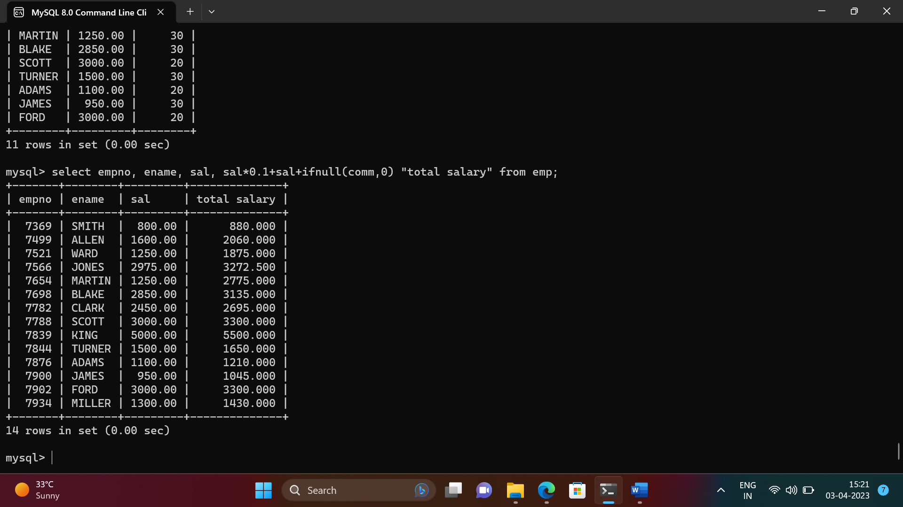

* 1. List the Name and job of the emp who have joined before 1 jan 1986 and whose salary range is between 1200and 2500. Display the columns with user defined Column headers.

select ename,job from emp where hiredate < '1986-01-01' and sal between 1200 and 2500;

+--------+----------+

| ename | job |

+--------+----------+

| ALLEN | SALESMAN |

| WARD | SALESMAN |

| MARTIN | SALESMAN |

| CLARK | MANAGER |

| TURNER | SALESMAN |

| MILLER | CLERK |

+--------+----------+

6 rows in set (0.00 sec)

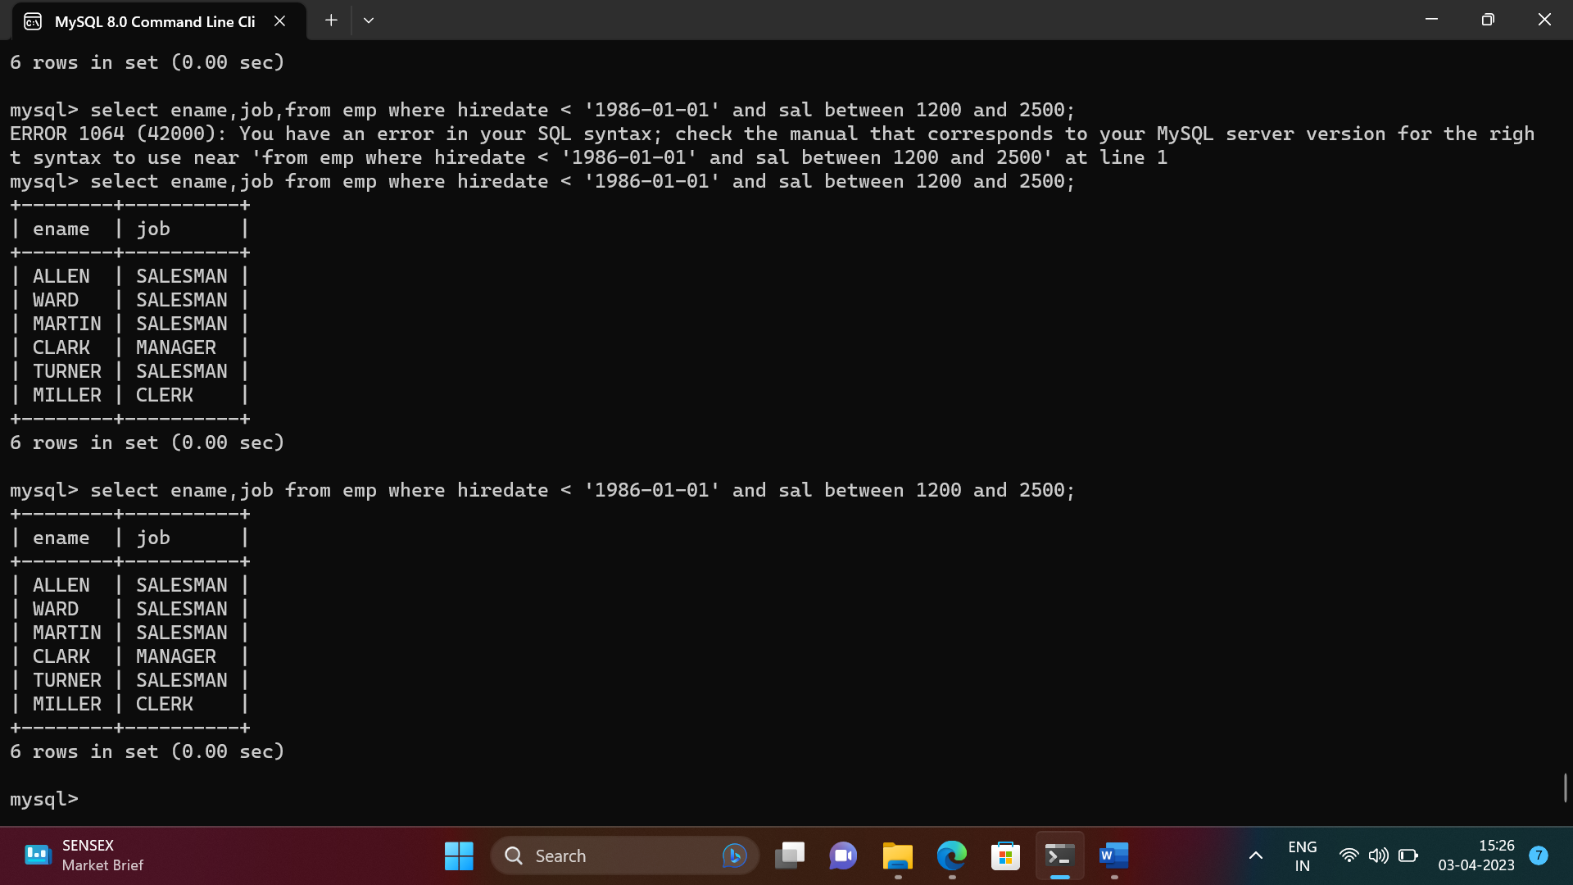

* 1. List the empno, name, and department number of the emp works under manager with id 7698

select empno, ename, deptno from emp where mgr = 7698;

+-------+--------+--------+

| empno | ename | deptno |

+-------+--------+--------+

| 7499 | ALLEN | 30 |

| 7521 | WARD | 30 |

| 7654 | MARTIN | 30 |

| 7844 | TURNER | 30 |

| 7900 | JAMES | 30 |

+-------+--------+--------+

5 rows in set (0.00 sec)

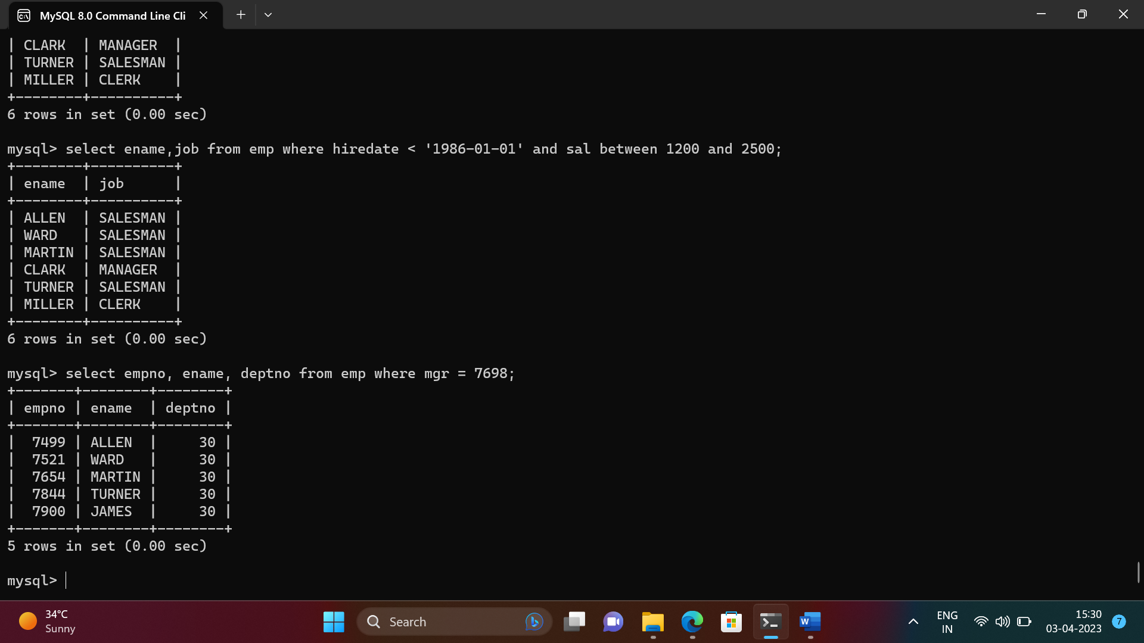

* 1. List the name, job, and salary of the emp who are working in departments 10 and 30.

select ename,job,sal from emp where deptno in (10,30);

+--------+-----------+---------+

| ename | job | sal |

+--------+-----------+---------+

| ALLEN | SALESMAN | 1600.00 |

| WARD | SALESMAN | 1250.00 |

| MARTIN | SALESMAN | 1250.00 |

| BLAKE | MANAGER | 2850.00 |

| CLARK | MANAGER | 2450.00 |

| KING | PRESIDENT | 5000.00 |

| TURNER | SALESMAN | 1500.00 |

| JAMES | CLERK | 950.00 |

| MILLER | CLERK | 1300.00 |

+--------+-----------+---------+

9 rows in set (0.00 sec)

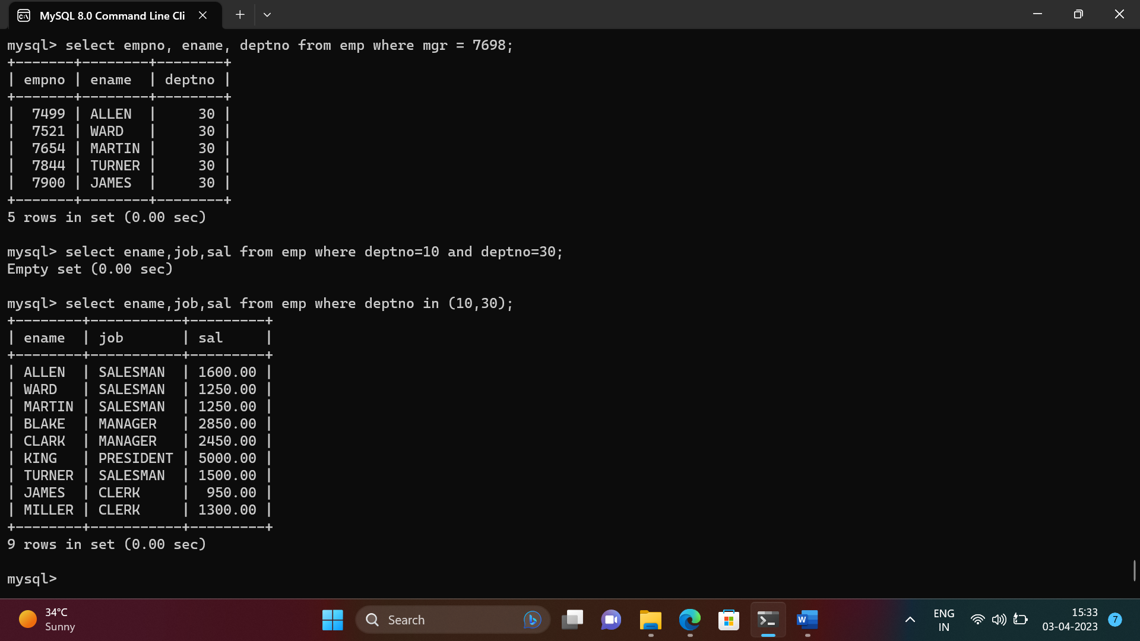

* 1. Display name concatenated with dept code separated by comma and space. Name

the column as ‘Emp info’.

select concat(ename,", ",deptno) as Emp_Info from emp;

+------------+

| Emp_Info |

+------------+

| SMITH, 20 |

| ALLEN, 30 |

| WARD, 30 |

| JONES, 20 |

| MARTIN, 30 |

| BLAKE, 30 |

| CLARK, 10 |

| SCOTT, 20 |

| KING, 10 |

| TURNER, 30 |

| ADAMS, 20 |

| JAMES, 30 |

| FORD, 20 |

| MILLER, 10 |

+------------+

14 rows in set (0.00 sec)

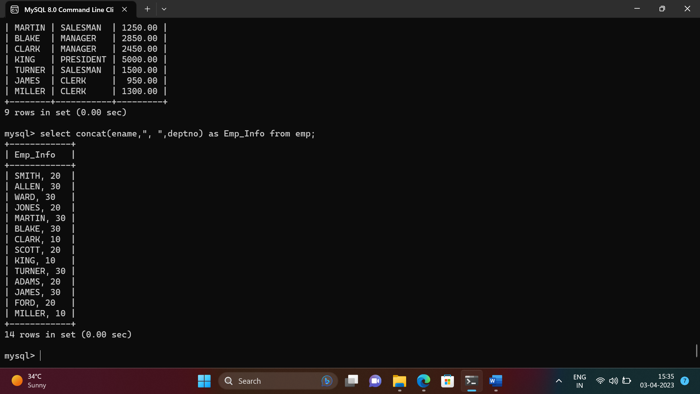

* 1. Display the emp details who do not have manager.

select * from emp where mgr is null;

+-------+-------+-----------+------+------------+---------+------+--------+

| EMPNO | ENAME | JOB | MGR | HIREDATE | SAL | COMM | DEPTNO |

+-------+-------+-----------+------+------------+---------+------+--------+

| 7839 | KING | PRESIDENT | NULL | 1981-11-17 | 5000.00 | NULL | 10 |

+-------+-------+-----------+------+------------+---------+------+--------+

1 row in set (0.00 sec)

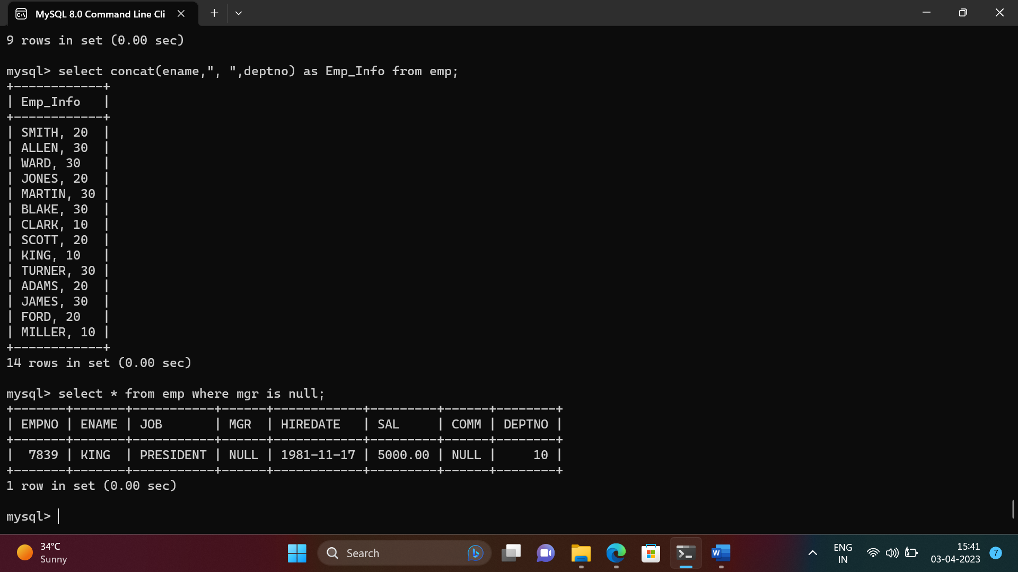

* 1. Write a query which will display name, department no and date of joining of all employee who were joined January 1, 1981 and March 31, 1983. Sort it based on date of joining (ascending).

select ename, deptno, hiredate from emp where hiredate between '1981-01-01' and '1983-03-31' order by hiredate;

+--------+--------+------------+

| ename | deptno | hiredate |

+--------+--------+------------+

| ALLEN | 30 | 1981-02-20 |

| WARD | 30 | 1981-02-22 |

| JONES | 20 | 1981-04-02 |

| BLAKE | 30 | 1981-05-01 |

| CLARK | 10 | 1981-06-09 |

| TURNER | 30 | 1981-09-08 |

| MARTIN | 30 | 1981-09-28 |

| KING | 10 | 1981-11-17 |

| JAMES | 30 | 1981-12-03 |

| FORD | 20 | 1981-12-03 |

| MILLER | 10 | 1982-01-23 |

| SCOTT | 20 | 1982-12-09 |

| ADAMS | 20 | 1983-01-12 |

+--------+--------+------------+

13 rows in set (0.00 sec)

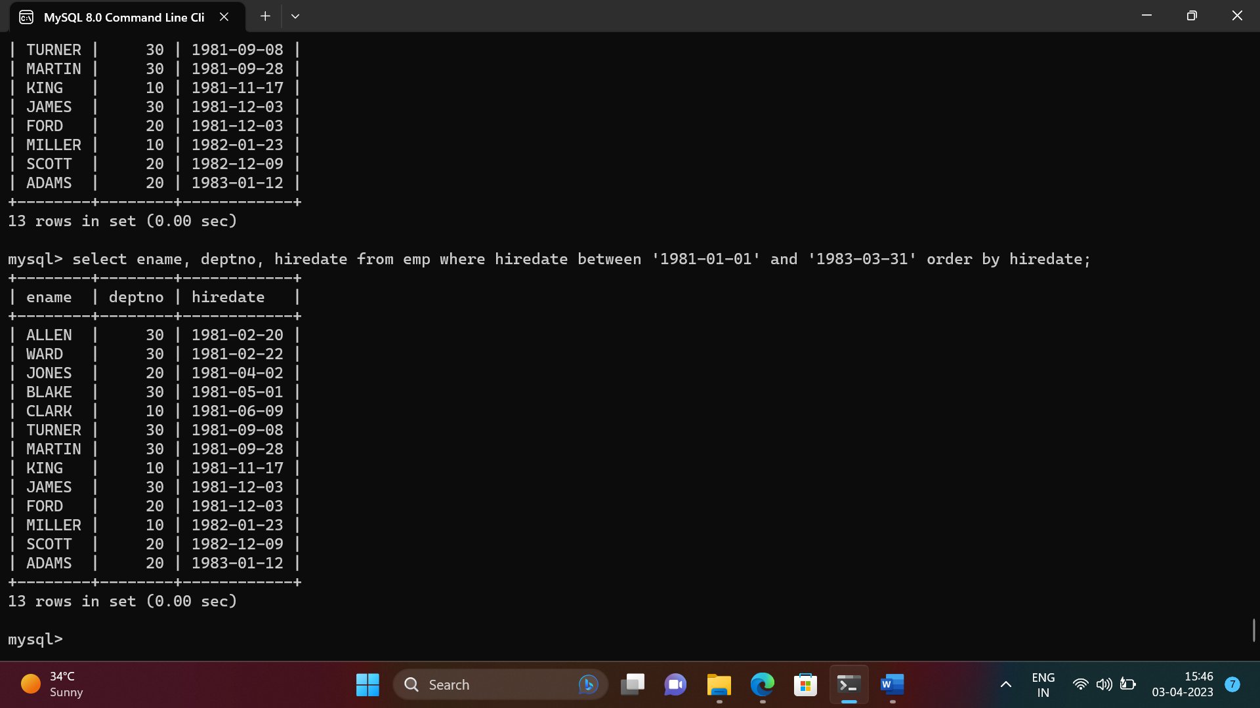

* 1. Display the employee details where the job contains word ‘AGE’ anywhere in the Job

select * from emp where job like '%age%';

+-------+-------+---------+------+------------+---------+------+--------+

| EMPNO | ENAME | JOB | MGR | HIREDATE | SAL | COMM | DEPTNO |

+-------+-------+---------+------+------------+---------+------+--------+

| 7566 | JONES | MANAGER | 7839 | 1981-04-02 | 2975.00 | NULL | 20 |

| 7698 | BLAKE | MANAGER | 7839 | 1981-05-01 | 2850.00 | NULL | 30 |

| 7782 | CLARK | MANAGER | 7839 | 1981-06-09 | 2450.00 | NULL | 10 |

+-------+-------+---------+------+------------+---------+------+--------+

3 rows in set (0.00 sec)

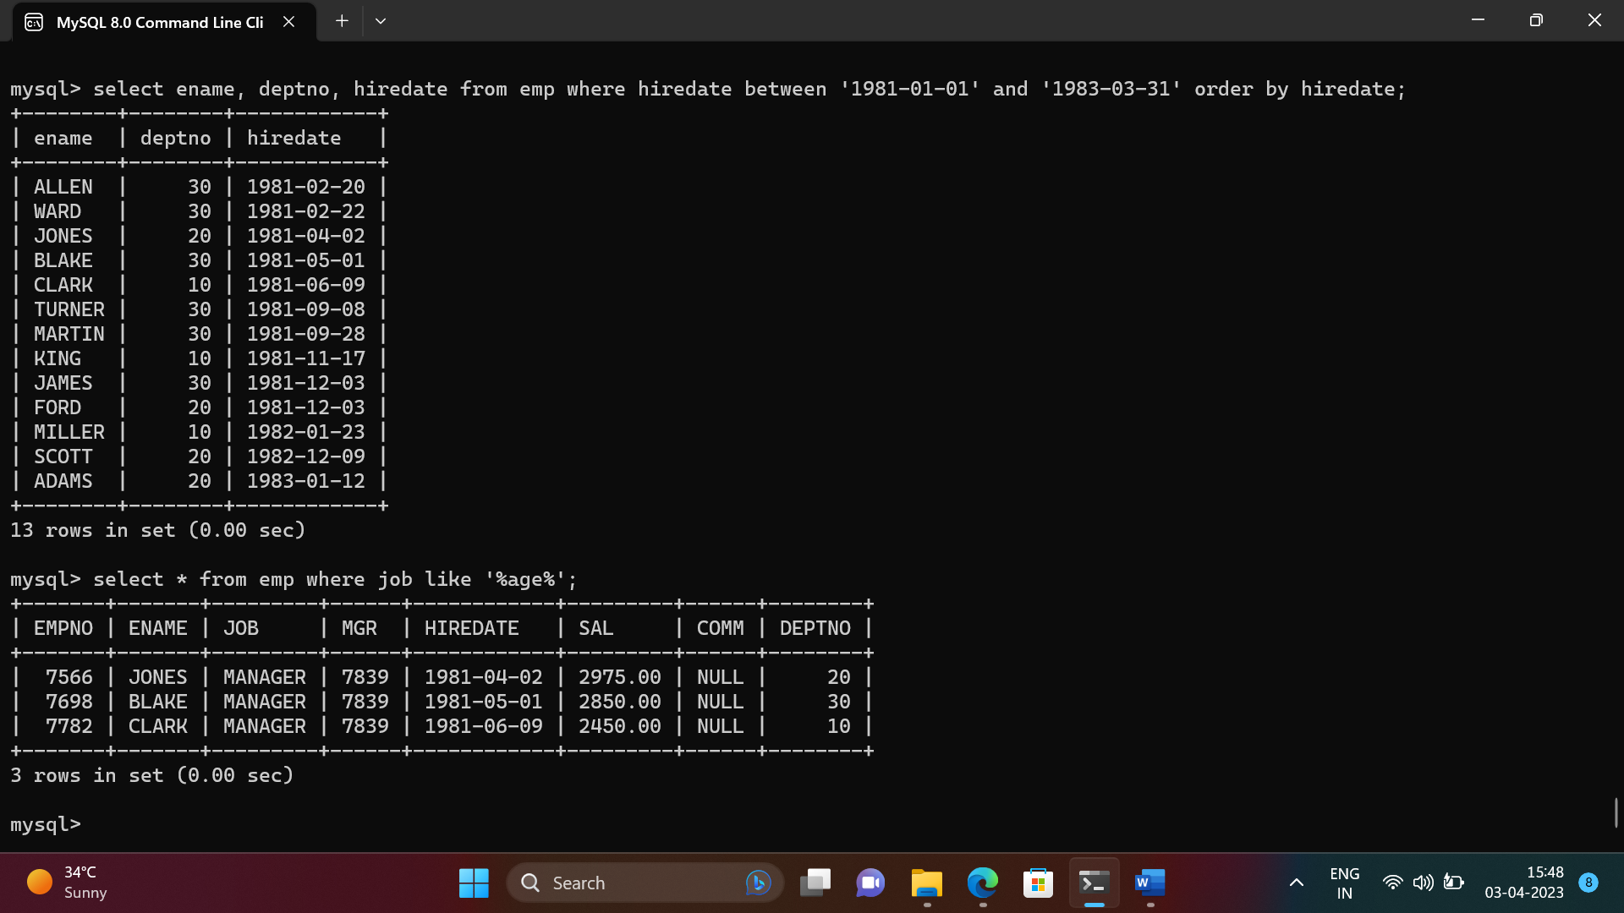

1. List the details of the employee , whose names start with ‘A’ and end with ‘S’ or

whose names contains N as the second or third character, and ending with either ‘N’ or ‘S’.

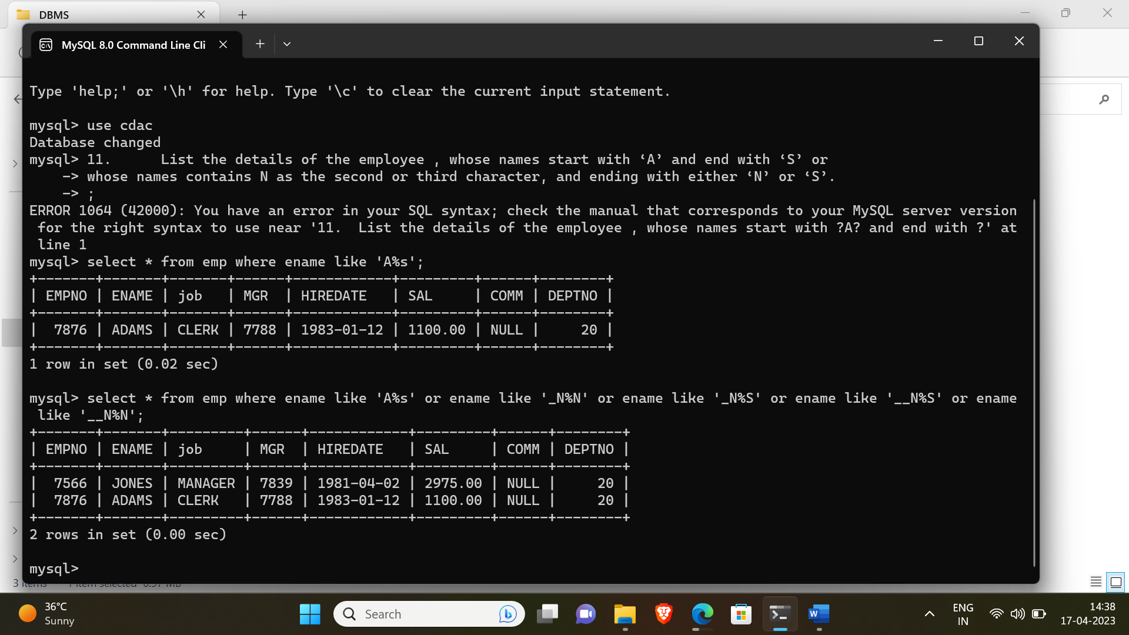

1. List the names of the emp having ‘_’ character in their name.

> select * from emp where ename REGEXP '_';

Empty set (0.00 sec)

Single Row functions

1. To list all employees and their email, to generate email use 2 to 5 characters from ename

Concat it with 2 to 4 characters in job and then concat it with ‘@mycompany.com’

select *,lower(concat(substr(ename,1,3),substr(job,1,3),"@mycompany.com")) email from emp ;

+-------+--------+-----------+------+------------+---------+---------+--------+----------------------+

| EMPNO | ENAME | JOB | MGR | HIREDATE | SAL | COMM | DEPTNO | email |

+-------+--------+-----------+------+------------+---------+---------+--------+----------------------+

| 7369 | SMITH | CLERK | 7902 | 1980-12-17 | 800.00 | NULL | 20 | smicle@mycompany.com |

| 7499 | ALLEN | SALESMAN | 7698 | 1981-02-20 | 1600.00 | 300.00 | 30 | allsal@mycompany.com |

| 7521 | WARD | SALESMAN | 7698 | 1981-02-22 | 1250.00 | 500.00 | 30 | warsal@mycompany.com |

| 7566 | JONES | MANAGER | 7839 | 1981-04-02 | 2975.00 | NULL | 20 | jonman@mycompany.com |

| 7654 | MARTIN | SALESMAN | 7698 | 1981-09-28 | 1250.00 | 1400.00 | 30 | marsal@mycompany.com |

| 7698 | BLAKE | MANAGER | 7839 | 1981-05-01 | 2850.00 | NULL | 30 | blaman@mycompany.com |

| 7782 | CLARK | MANAGER | 7839 | 1981-06-09 | 2450.00 | NULL | 10 | claman@mycompany.com |

| 7788 | SCOTT | ANALYST | 7566 | 1982-12-09 | 3000.00 | NULL | 20 | scoana@mycompany.com |

| 7839 | KING | PRESIDENT | NULL | 1981-11-17 | 5000.00 | NULL | 10 | kinpre@mycompany.com |

| 7844 | TURNER | SALESMAN | 7698 | 1981-09-08 | 1500.00 | 0.00 | 30 | tursal@mycompany.com |

| 7876 | ADAMS | CLERK | 7788 | 1983-01-12 | 1100.00 | NULL | 20 | adacle@mycompany.com |

| 7900 | JAMES | CLERK | 7698 | 1981-12-03 | 950.00 | NULL | 30 | jamcle@mycompany.com |

| 7902 | FORD | ANALYST | 7566 | 1981-12-03 | 3000.00 | NULL | 20 | forana@mycompany.com |

| 7934 | MILLER | CLERK | 7782 | 1982-01-23 | 1300.00 | NULL | 10 | milcle@mycompany.com |

+-------+--------+-----------+------+------------+---------+---------+--------+----------------------+

14 rows in set (0.00 sec)

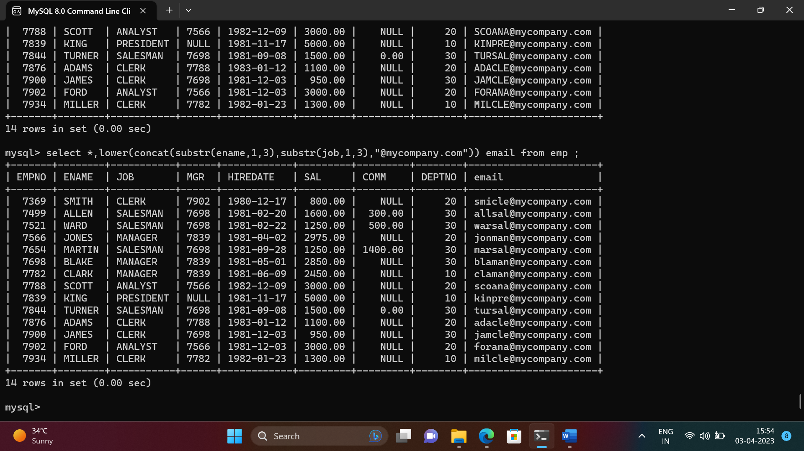

1. List all employees who joined in September.

select * from emp where monthname(hiredate) = 'september';

+-------+--------+----------+------+------------+---------+---------+--------+

| EMPNO | ENAME | JOB | MGR | HIREDATE | SAL | COMM | DEPTNO |

+-------+--------+----------+------+------------+---------+---------+--------+

| 7654 | MARTIN | SALESMAN | 7698 | 1981-09-28 | 1250.00 | 1400.00 | 30 |

| 7844 | TURNER | SALESMAN | 7698 | 1981-09-08 | 1500.00 | 0.00 | 30 |

+-------+--------+----------+------+------------+---------+---------+--------+

2 rows in set (0.00 sec)

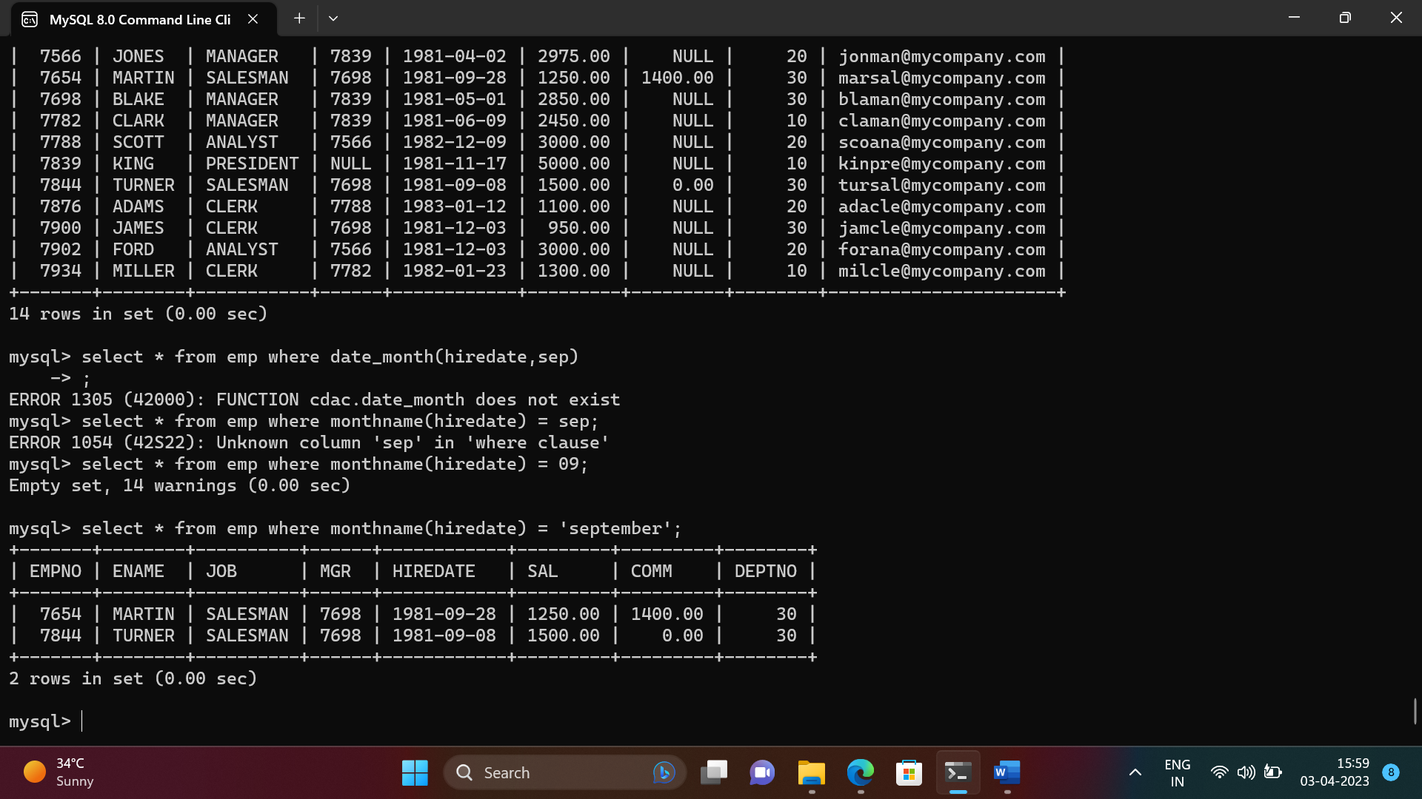

1. List the empno, name, and department number of the emp who have experience of 18 or more years and sort them based on their experience.

select empno,ename,deptno, floor((datediff(curdate(),hiredate)/365)) as Exp from emp where floor((datediff(curdate(),hiredate)/365)) > 18 ;

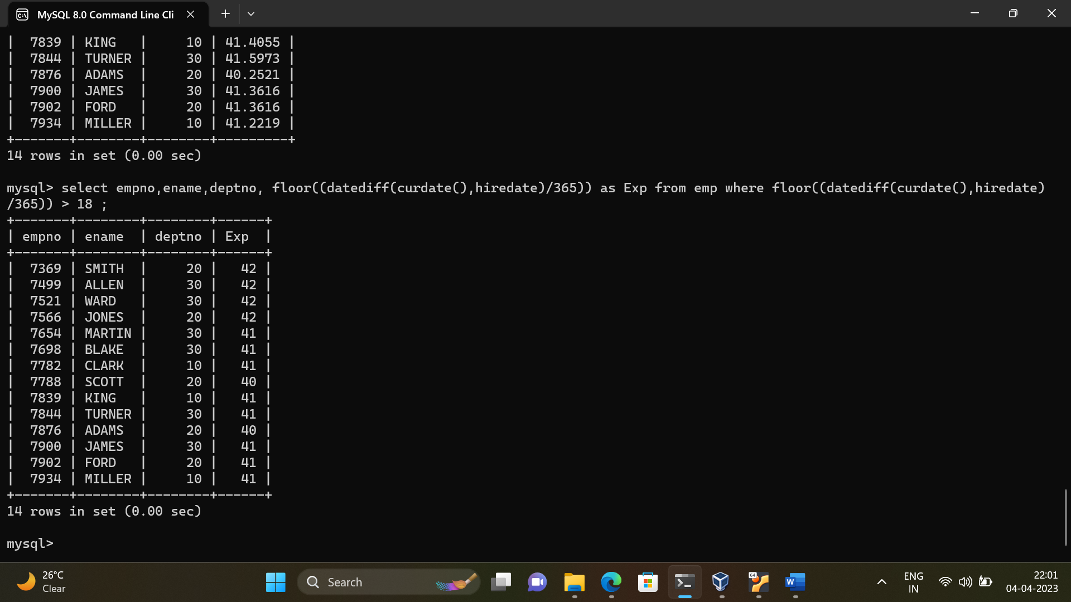

1. Display the employee details who joined on 3rd of any month or any year

select * from emp where day(hiredate)=3;

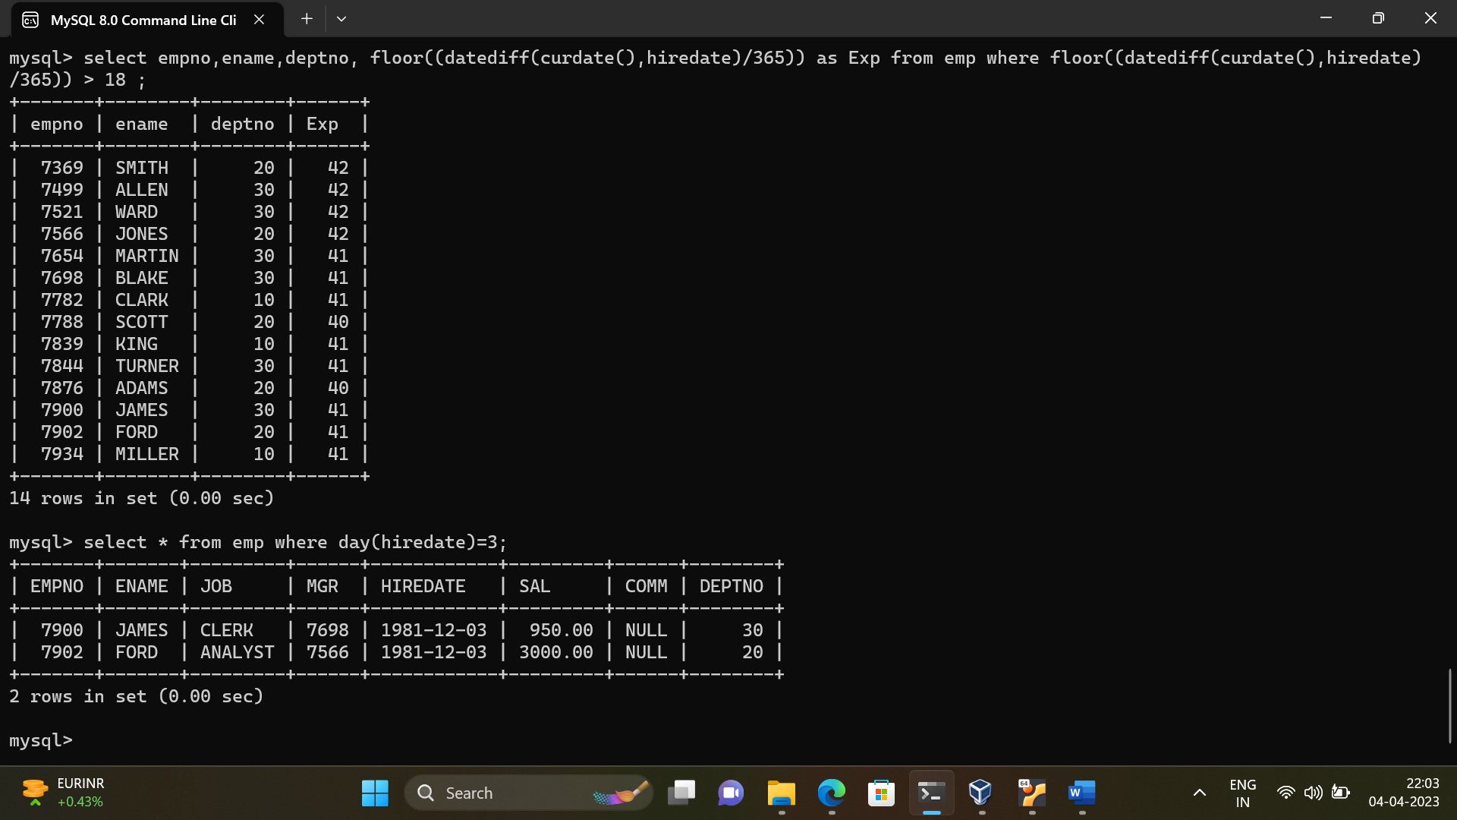

1. display all employees who joined between years 1981 to 1983.

select * from emp where year(hiredate) between 1981 and 1983;

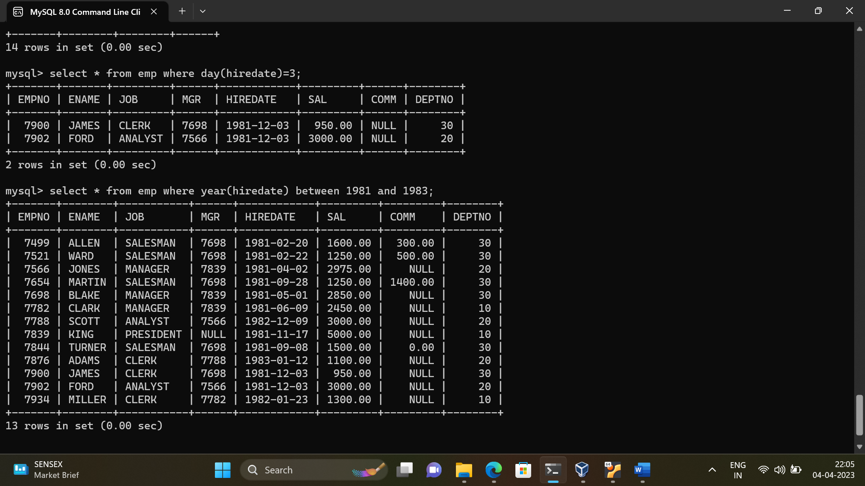

Group functions

1. Display the Highest, Lowest, Total & Average salary of all employee. Label the columns Maximum, Minimum, Total and Average respectively for each Department. Also round the result to the nearest whole number.

-> select round(max(sal)) Maximum,round(min(sal),2) Minimum, round(Avg(sal),2) Average, round(sum(sal),2) Sum from emp group by deptno;

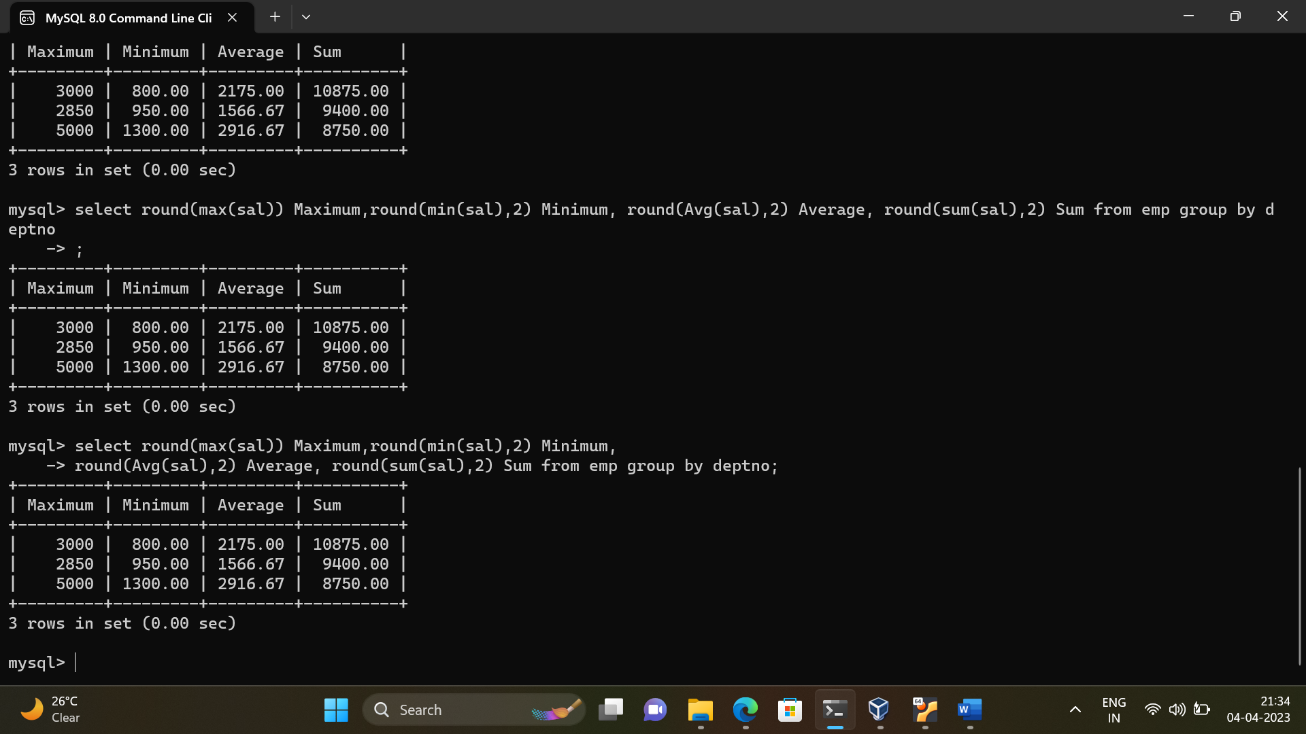

1. Display Department no and number of managers working in that department. Label the

column as ‘Total Number of Managers’ for each department.

-> select deptno, count(mgr) from emp group by deptno;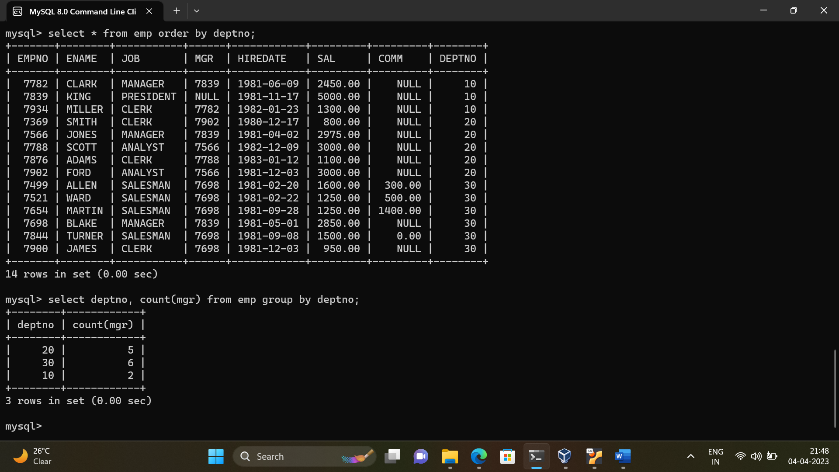

1. Get the Department number, and sum of Salary of all non managers where the sum is greater than 20000.

Select deptno, sum(sal) from emp where empno not in (7839,7782,7902,7566,7788,7698) group by deptno having sum(sal)>20000;

